
13/10/2019
DECRIPTION ON EXAUST FANS | WRITTEN BY:DEHYA KHURRAIM SIDDQUI & SAFDER REHMAN
FANoFAN | EXAUST FANS

Table of Contents

TURBO HEAVY DUTY ------------------------------------------------------3
CRIPS AIR PRIME CV ------------------------------------------------------5
TURBO DBB ------------------------------------------------------7
CRIPS AIR PRIME AS PLUS ------------------------------------------------------9
CRIPS AIR PRIME BV ------------------------------------------------------11
TURBO STRIKER ------------------------------------------------------13
CRIPS AIR PRIME AF ------------------------------------------------------15
TURBO JET DELUX ------------------------------------------------------17
CRIPS AIR LX 250 ------------------------------------------------------19
CRIPS AIR PRIME BV 100 ------------------------------------------------------21
CRIPS AIR LX 200 ------------------------------------------------------23
CRIPS AIR ------------------------------------------------------25
CRIPS AIR LX 100 ------------------------------------------------------27

Figures
Figure 1 3
Figure 2 5
Figure 3 7
Figure 4 9
Figure 5 13
Figure 6 15
Figure 7 17
Figure 8 19
Figure 9 21
Figure 10 23Figure 11 25
Figure 12 27

TUBO HIGH DUTY

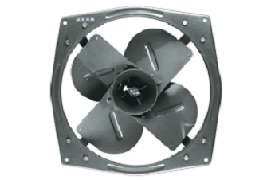
Figure 1
COLOUR: METALLIC GREY SPEED: 900/1400 RPM
SWEEP: 300 mm Power Input: 55/90 W Air Delivery: 1145/1710 M³/Min PRICE: RS 3630

KEY FEATURE:

RPM 900/1400 1145/1710 m³/h 300 MM
SPECIFICATION:
Volts | 230V
Wattage | 55/90W
Warranty | 1 year
Sweep Size (mm) | 300
RPM @ 230v | 900/1400
CRISP AIR PREMIA CV

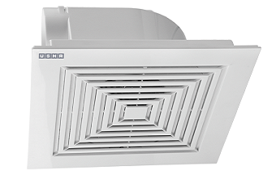
Figure 2
COLOUR: WHITE SPEED: 1050 RPM
SWEEP: 120 mm Power Input: 19 W
Air Delivery: 100 M³/Min PRICE: RS 2300

KEY FEATURE:
RPM 1050 100 m³/h 120MM
SPECIFICATION:
Volts | 230V
Wattage | 19W
Warranty | 2 year
Sweep Size (mm) | 120
RPM @ 230v | 1050
TURBO DD

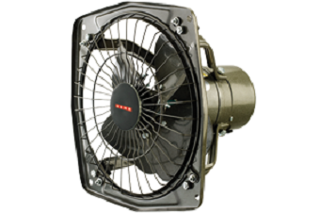
Figure 3
COLOUR: METALLIC GREY SPEED: 1400 RPM
SWEEP: 230 mm Power Input: 45 W
Air Delivery: 750 M³/Min PRICE: RS 1960

KEY FEATURE:
RPM 1400 750 m³/h 230MM
SPECIFICATION:
Volts | 230V
Wattage | 45W
Warranty | 1 year
Sweep Size (mm) | 230
RPM @ 230v | 1400
CRISP AIR PREMIA CV AS PLUS

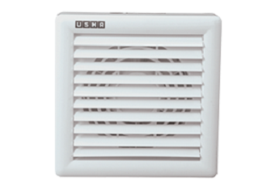
Figure 4
COLOUR: WHITE SPEED: 1800 RPM
SWEEP: 150 mm Power Input: 24 W
Air Delivery: 220M³/Min PRICE: RS 1850

KEY FEATURE:
RPM 1800 220 m³/h 150MM
SPECIFICATION:
Volts | 230V
Wattage | 24W
Warranty | 2 year
Sweep Size (mm) | 150
RPM @ 230v | 1800
CRISP AIR PREMIA CV BV

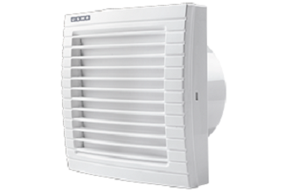
Figure 5
COLOUR: WHITE SPEED: 1350 RPM
SWEEP: 150 mm Power Input: 21 W
Air Delivery: 210M³/Min PRICE: RS 1740

KEY FEATURE:
RPM 1350 210 m³/h 150MM
SPECIFICATION:
Volts | 230V
Wattage | 21W
Warranty | 2 year
Sweep Size (mm) | 150
RPM @ 230v | 1350
TURBO STRIKER

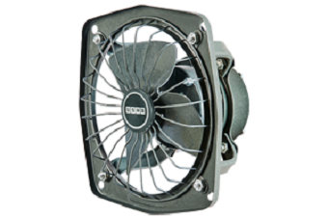
Figure 6
COLOUR: METALLIC GREY SPEED: 2500 RPM
SWEEP: 230 mm Power Input: 55 W
Air Delivery: 1000M³/Min PRICE: RS 1670

KEY FEATURE:
RPM 2500 1000 m³/h 230MM
SPECIFICATION:
Volts | 230V
Wattage | 55W
Warranty | 2 year
Sweep Size (mm) | 230
RPM @ 230v | 2500
CRISP AIR PREMIA CV AF
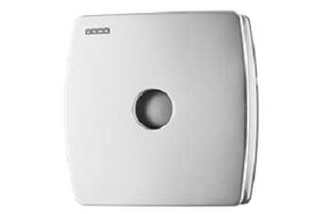

Figure 7
COLOUR: STAINLESS STEEL SPEED: 1800 RPM
SWEEP: 150 mm Power Input: 21 W
Air Delivery: 350M³/Min PRICE: RS 1580

KEY FEATURE:
RPM 1800 350 m³/h 150MM
SPECIFICATION:
Volts | 230V
Wattage | 21W
Warranty | 2 year
Sweep Size (mm) | 150
RPM @ 230v | 1800
TURBO JET

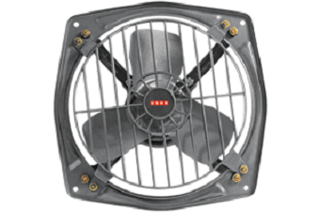
Figure 8
COLOUR: METALLIC GREY SPEED: 1325 RPM
SWEEP: 300 mm Power Input: 63 W
Air Delivery: 1050M³/Min PRICE: RS 1560

KEY FEATURE:
RPM 1325 1050 m³/h 300MM
SPECIFICATION:
Volts | 230V
Wattage | 63W
Warranty | 2 year
Sweep Size (mm) | 300
RPM @ 230v | 1325
CRISP AIR LX 250mm

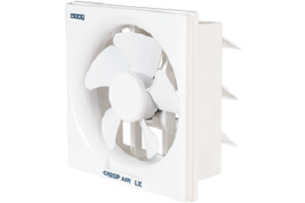
Figure 9
COLOUR: WHITE SPEED: 1250 RPM
SWEEP: 250 mm Power Input: 45 W
Air Delivery: 479M³/Min PRICE: RS 1470

KEY FEATURE:
RPM 1250 479 m³/h 250MM
SPECIFICATION:
Volts | 230V
Wattage | 45W
Warranty | 2 year
Sweep Size (mm) | 250
RPM @ 230v | 1250
CRISP AIR PREMIA BV 100

Figure 10
COLOUR: WHITE SPEED: 2250 RPM
SWEEP: 100 mm Power Input: 12 W
Air Delivery: 70M³/Min PRICE: RS 1440

KEY FEATURE:
RPM 2250 70 m³/h 100MM
SPECIFICATION:
Volts | 230V
Wattage | 10W
Warranty | 2 year
Sweep Size (mm) | 100
RPM @ 230v | 2250
CRISP AIR PREMIA LX 200

Figure 11
COLOUR: WHITE SPEED: 1300 RPM
SWEEP: 200 mm Power Input: 40 W
Air Delivery: 282M³/Min PRICE: RS 1380

KEY FEATURE:
RPM 1300 282 m³/h 200MM
SPECIFICATION:
Volts | 230V
Wattage | 40W
Warranty | 2 year
Sweep Size (mm) | 200
RPM @ 230v | 1300
CRISP AIR

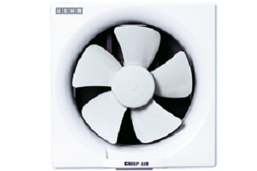
Figure 12
COLOUR: WHITE SPEED: 1386 RPM
SWEEP: 150 mm Power Input: 30 W
Air Delivery: 90M³/Min PRICE: RS 1290

KEY FEATURE:
RPM 1386 90 m³/h 150MM
SPECIFICATION:
Volts | 230V
Wattage | 30W
Warranty | 2 year
Sweep Size (mm) | 150
RPM @ 230v | 1386
CRISP AIR PREMIA LX 150

Figure 4
COLOUR: WHITE SPEED: 1350 RPM
SWEEP: 150 mm Power Input: 40 W
Air Delivery: 153M³/Min PRICE: RS 1290

KEY FEATURE:
RPM 1350 153 m³/h 150MM
SPECIFICATION:
Volts | 230V
Wattage | 40W
Warranty | 2 year
Sweep Size (mm) | 150
RPM @ 230v | 1350

WRITTEN BY

DEHYA KHURRAIM SIDDQUI : WEB DESIGNER
SAFDER REHMAN : WEB EDITOR

IN SUPPERVISION OF

MISS ALMAS.

WEBSITE LINK

